- Of the risks that you identify at the store level, which one do you think could most adversely affect the income statement, balance sheet, and cash flow statement, and give an example of how it could adversely affect the financial statements?

Starbucks Corporation has highlighted ten risk factors that would adversely affect its incomes statements entries. Of the ten risk factors, incidents involving food and beverages would be presented as a risk factor at the store levels. Unauthorized access, theft, and property destruction would adversely result in massive changes in the financial statement entries. Besides, theft of Starbucks stock, such as refrigerated beverages, leads to a decrease in stock with no corresponding increase in revenue. Since inventory can be stolen, it follows that the financial statements will be affected directly since inventory directly affects income, profit margins, and financial ratios. In most Starbucks outlets, food and beverages are displayed on glass for consumers to select from their wide range of products. This poses a high risk of theft for both the employees and customers.
Take, for instance, theft of coffee has accumulated to almost 20% of the original stock.
- [Income Statement] This results in a decline in the CPG, Foodservice, and others for the fiscal year 2019 on Income Statement by 20%. The 'What If Analysis' conducted on the data, a decrease in the CPG and Foodservice by 20%, entries in the total revenues, operating income, and earning became affected.
- [Balance Sheet] In the balance sheet, the 20% decrease in the CPG and Foodservice results in a decrease in the cash and cash equivalences from 2686.6USD to 2268.8USD. It then follows that both current and total assets decrease and a net decrease in the total shareholder’s equity.
- [Cash Flow Statement] On the Cash Flow Statement, the 20% decrease in CPG and Foodservice (Income Statement) causes the net earnings, including non-controlling interest, to decrease from 3594.6USD to 3176.8USD. This causes a decrease in the net cash provided by operating activities and cash and cash equivalences.
- [Ratios] Since the 20% decrease in the Income Statement affects the Net sales revenue, Net Income, Gross profit, Current and Total Assets, Cash and Cash Equivalences, and Cash flow from Operating Activities, then almost all the financial ratios are affected except the Inventory turnover ratio which is given by
- Inventory Turnover Ratio = Cost of Sales/Average Inventory.
- [Charts] Using excels what-if scenario manager to select the new values/scenarios listed observe the changes in the correlated charts tab in the spreadsheet.

NOTE: For Parts (a), (b), (c), and (d), in Excel go to Data -> What-if -> Scenario Manager -> Select the programed What-if Scenarios I’ve listed. Observe the purple data that is changed based on the What-If scenario and observe the corresponding changes on the yellow sets of data which is explained in this document. Each workbook IS, BS, CF and Ratios contain different programmed scenarios. For charts once scenarios from IS, BS, CF and Ratios is loaded, the charts will reflect that change observe the difference. For ratios zoom out to 55% to see the changes fully.
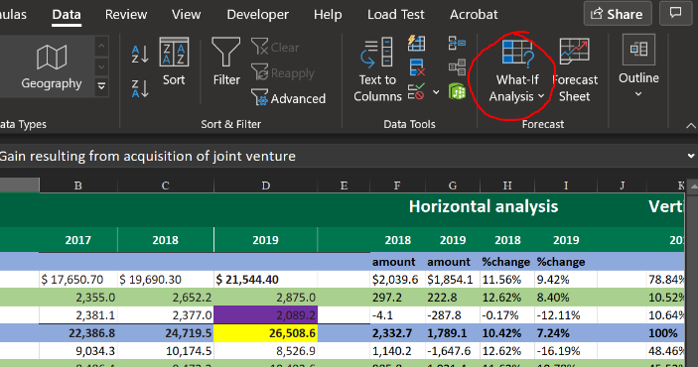
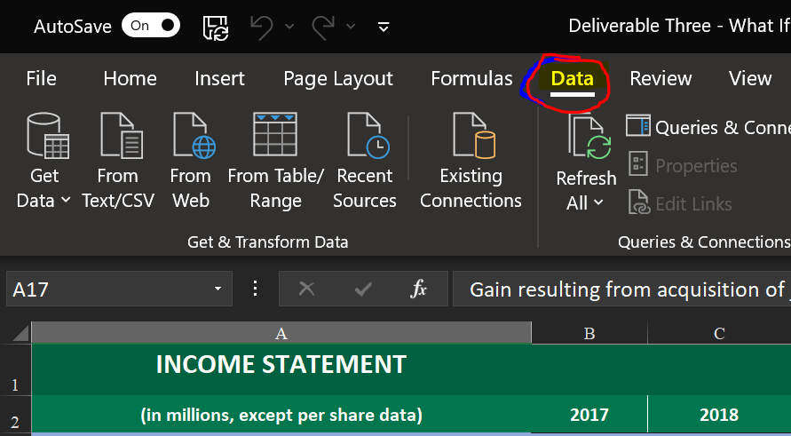

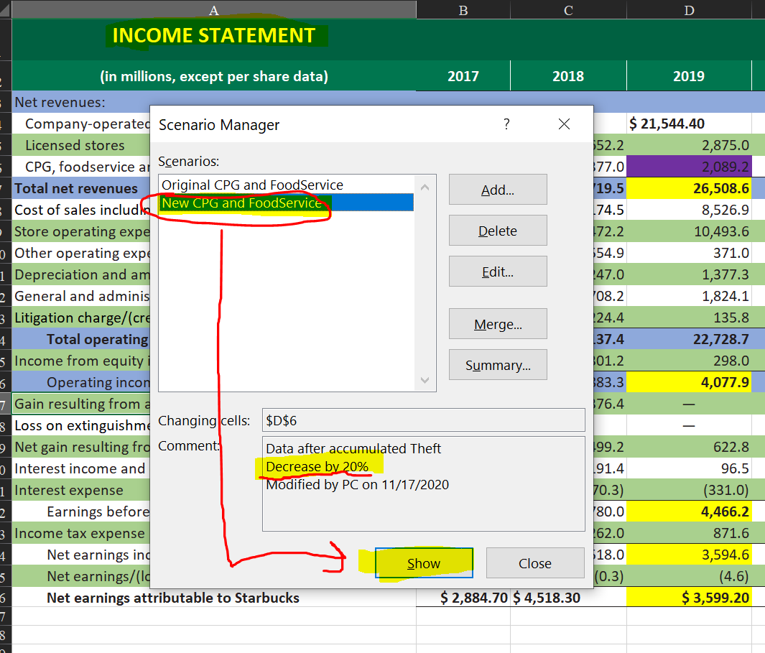

- What items do you believe have the highest and lowest gross profit margin?

The Starbuck refrigerator is used to display all of the products sold by Starbucks except for hot coffee made on-demand. Starbucks' most selling products are beverages with a revenue of 74% and packaged and single-serve tea and coffees, with 1% of the total Starbucks sales (Starbuck 10-K Report, p. 2). Therefore, this makes beverages have the highest gross profit margins, and packaged single-serve coffee and tea to have the lowest profit margins.

- If a person steals one of the high gross profit margin inventory items, how many more of these items does Starbucks have to sell to make up the cost of the stolen item? How many for the lowest gross profit margin inventory items? Demonstrate your understanding by providing calculations to support your claim.

Vanilla Latte is the most selling product of Starbuck in the US and the outside world as well. The market price of a single can of Vanilla Latte is 3.45USD. If a store has 500 cartons with a capacity of 24 cups of Vanilla Late, then the operating inventory of the store is;
$$Value of Inventory=500×24×3.45=\$ 45,400$$
If 20% of the inventory disappear and goes unrecorded, the cost of sales reduces to;
$$Cost of Sales=\frac{80}{100}×45400=36,320$$
The company loses $9,080 that can be recovered by selling extra 5cups;
$$\frac{45400}{9080}=5cups$$
If the recovery is not made, then the
$$Gross Profit=Sales Rvenue-Cost of Goods sold$$
$=36,320-45400=-9080$ (lose)
$$Profit Margin=\frac{Gross Profit}{Net Sales Revenue}$$
$$=\frac{-9080}{45400}=-0.02=-2\% (Net loss)$$
Starbuck encounters a net loss of 2% if the stolen inventory is not recovered at the store level.

- To see a practical effect on Starbucks ' financial statements, imagine one of the lowest profit margin refrigerated items is stolen once per day in every Starbucks store worldwide for an entire year. How much would that affect the Cost of Sales? How many more of those items would Starbucks have to sell to make up the loss? (You need to know approximately how many Starbucks owned company stores there are worldwide. If you do not know, estimate it). Would it make a difference if LIFO, FIFO, or average inventory cost flow systems are used? If you believe so, briefly explain how.

Yes, Starbuck has many stores operating worldwide, and the loss of a single cup of the least selling product would result in the loss of millions of Dollars in the LIFO inventory. As of September 2019, Starbucks had 31,286 operating stores worldwide. The lowest selling Starbucks product is Chantico drinkable dessert and cost 2.65USD per cup. If one of this product is stolen every day from all of Starbucks operated stores, then in one year, the company loses (estimated)
$$Gross loss=1×2.65×365×31286=\$ 30,261,383.50$$

- Starbucks has many fixed assets in its stores. For example, they have various machines to make drinks or cook food. Identify one of those pieces of equipment and conduct internet research to estimate a replacement cost if the equipment were destroyed today, assuming it is January 1st (cost).
  - How many years do you estimate it will be functional and useful to help Starbucks produce revenue (estimated useful life)? In that period in the future, how much do you think Starbucks can sell it for (salvage value)?
In all Starbucks outlets, there are refrigerators for keeping and displaying Starbucks products. A single set of a Starbucks refrigerator is approximately $600 (Alibaba, 2020). The refrigerator can serve the company for over 20years, a period through which Starbuck would have realized enough revenue. If the fridge was to be sold later after 20year and considering the depreciation rate at 3%, the company could sell it at $326.28.
$$Amount=600({1-3/{100})}^{20}=\$326.28$$
After 1year, the value of the refrigerator will be $582
$$Amount after 1yr=600({1-3/{100})}^{20}=\$582$$
The depreciation expense, therefore, for the refrigerator is $600 - 582=$ 18
In one year, the depreciation expense for all Starbuck stress will be
$$Depreciation Expense=18×31286=\$562,148$$
On the Income Statement, the depreciation of the refrigerator will result in a general increase in the depreciation and amortization expenses and a corresponding decrease in operating income. In the Balance Sheet, Assets' net value will decrease due to a decrease in property value. At the store level, the refrigerator expense is at $18, which may not be noticeable, but at the firm level, this is a huge expense of $562,148 across all the 31,286 Starbucks stores across the world.

- What would you change that would help it increase revenue, control its expenses, or make its assets more efficient? Show how that beneficial change would affect at least one Ratio in the next year that financial statements would be produced.

As management, I would increase incentives such as spot awards to the consumers. This will increase traffic and, in turn, boost net sales. An increase in net sales revenue increases in gross profit. An increase in gross profit results in an increase in profit margin, profit margin ratio, and receivable turnover ratios.

- Based on how much you determined the financial statements could be altered if the risk(s) you identified came true, do you feel that management adequately discussed the store level risks? Did they say enough? Too much? A perfect description?

The management has done a good job in explaining the store-associated risks. The description offered in the K-10 Reports reveals all the possible sources of alterations in the Starbucks financial statements. The company mostly explains security threats resulting from cybersecurity and unauthorized access by the third party. In their explanation, the management has failed to discuss threats resulting from within the company wall, such as theft of company products from operating stores and licensed stores. The K-10 report description would be exceptional if it highlighted this as part of the risks that would adversely affect Starbucks' financial statement as calculated in the ‘What If Analysis’ Scenario manager.

Reference
- Form 10-K Starbucks Corp 2019 Annual report [PDF]

